Name : | Muhammad Taha
CMS ID : | 518133
Lesson Set  8 | Nested For Loop and  While Loop
Purpose | - Understand the purpose and usage of Nested for loop.  - Understand the purpose and usage of Nested While loop.  - Syntax and Rules of nested loops
Procedure | - Students should read the Pre-lab Reading Assignment before coming to lab.  - Students should complete the Pre-lab Writing Assignment before coming to lab.  - In the lab, students should complete Labs 8.1 through 8.2 in sequence.  - Your instructor will give further instructions as to grading and completion of the lab.  - Students should complete the set of lab tasks before the next lab and get them checked by their lab instructor.
 | Contents | Pre-requisites | Completion Time | Page Number
 | Pre-lab Reading Assignment | - | 20 min
 | Pre-lab Writing Assignment | Pre-lab Reading | 10 min
 | Lab 8
 | Lab 8.1  Working with Nested for loop | Understanding Nested for loop | 30 min
 | Lab 8.2  Working with Nested while loop | Understanding Nested while loop | 30 min

Pre-lab Reading Assignment

Nested Loop | A loop can be nested inside another loop. C++ allows at least 256 levels of nesting.  A nested loop is a loop within a loop, an inner loop within the body of an outer one. How this works is that the first pass of the outer loop triggers the inner loop, which executes to completion. Then the second pass of the outer loop triggers the inner loop again. This repeats until the outer loop finishes. Of course, a break within either the inner or outer loop would interrupt this process.
Syntax  Nested for loop | for ( init; condition; increment ) {  for ( init; condition; increment ) {  statement(s);  }  statement(s); // you can put more statements.  }
Flowchart  Nested for loop | 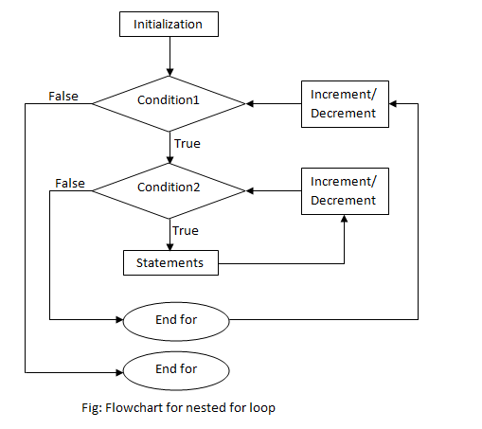
Example  Nested For Loop | The following program uses a nested for loop to find the prime numbers from 2 to 100.  #include <iostream>  using namespace std;  int main () {  int i, j;  for(i = 2; i<100; i++) {  for(j = 2; j <= (i/j); j++)  if(!(i%j)) break; // if factor found, not prime  if(j > (i/j)) cout << i << " is prime\n";  }  return 0;  }
Syntax  Nested While loop | while(condition) {  while(condition) {  statement(s);  }  statement(s); // you can put more statements.  }
Flowchart  Nested While Loop | 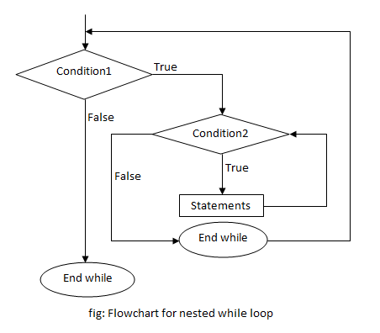
Example Nested While loop | #include <iostream>  using namespace std;  int main () {  // Local variable declaration:  int a = 1;  int b = 1;  // while loop execution  while( a < 10 ) {  while(b<10){  cout << "value of a and b is= " <<a*b << endl;  b++;  }  a++;  }  return 0;  }

Pre lab writing assignment
Fill in the blanks | 1. A loop can be nested inside of another Loop.  2. C++ allows at least 256 levels of Nesting.  3. An inner loop within the body of an Outer Loop.  4. An event controlled loop that is not guaranteed to execute at least once is the While Loop.  5. We can use break within either the Inner or Outer loop would interrupt that process.

Lab 8
Lab 8.1 | - Once you have opened the visual studio copy the following code in the code editor, try to run the code and observe the output. Write down the output that appears on the screen in the space given below  #include <iostream>  using namespace std;  int main()  {  int N = 5;  int M = 1;  for (int i = 0; i < N; i++)  {  for (int j = 1; j < M; j++)  {  cout << j;  }  cout << endl;  M++;  }  system("pause");  return 0;  }  PS F:\Programming Fundamental\Labs\Lab 08> g++ test.cpp  PS F:\Programming Fundamental\Labs\Lab 08> .\a.exe  1  12  123  1234  Press any key to continue . . .
Lab 8.2 | - Create a new project with new file with name lab8.2.cpp extension, copy the following code it and try to fill the missing code of the program. Observe the output that appears and write it in the box given below  #include <iostream>  using namespace std;  int main()  {  int N = 5;  int M = N;  for (int i = 0; i < N; i++)  {  for (int j = 1; j <= M; j++)  {  cout << j;  }  cout << endl;  M--;  }  system("pause");  return 0;  }  PS F:\Programming Fundamental\Labs\Lab 08> g++ test.cpp  PS F:\Programming Fundamental\Labs\Lab 08> .\a.exe  12345  1234  123  12  1  Press any key to continue . . .
Lab 8.3 | - Create a new project with name lab8.3.cpp extension, copy the following code it and try to run the program. Observe the output that appears and write it in the box given below  #include <iostream>  using namespace std;  int main () {  // Local variable declaration:  int a = 1;  int b = 1;  // while loop execution  while( a < 10 ) {  while(b<10){  cout << "value of a and b is= "<<a*b<< endl;  b++;  }  a++;  }  return 0;  }  PS F:\Programming Fundamental\Labs\Lab 08> g++ test.cpp  PS F:\Programming Fundamental\Labs\Lab 08> .\a.exe  value of a and b is= 1  value of a and b is= 2  value of a and b is= 3  value of a and b is= 4  value of a and b is= 5  value of a and b is= 6  value of a and b is= 7  value of a and b is= 8  value of a and b is= 9

Lab 8 | Lab Tasks

- Create a C++ program to print the number pattern with nested for loop.
1
1 2
1 2 3
1 2 3 4
1 2 3 4 5
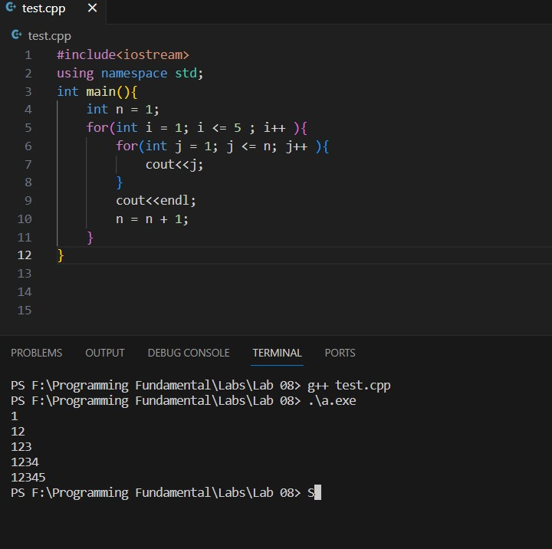

- C++ program to print the given star with nested while loop.

*
**
***
****
*****
